Revelation 9:10
10And they had tails like unto scorpions, and there were stings in their tails: and their power was to hurt men five months.
Scientists grow "mini human brains" from stem cells
http://news.yahoo.com/scientists-grow-mini-human-brains-stem-cells-130936086.html
Animal-Human Hybrids Spark Controversy
http://news.nationalgeographic.com/news/2005/01/0125_050125_chimeras.html
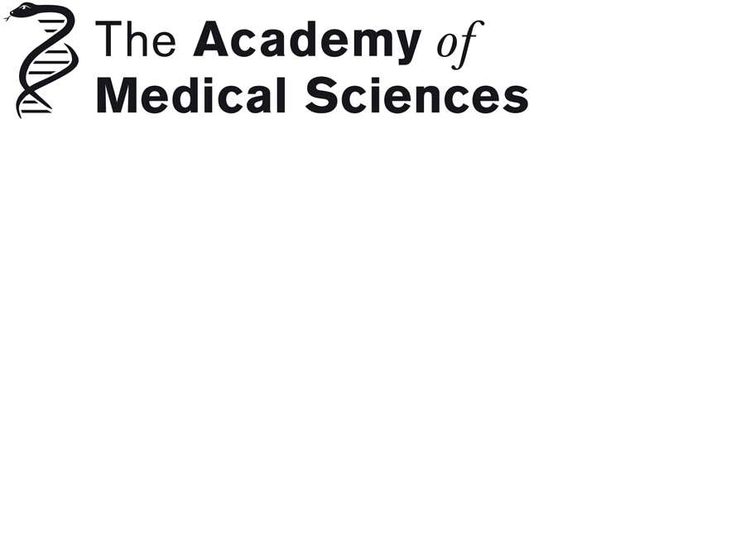
http://www.acmedsci.ac.uk/download.php?file=/images/pressRelease/ACHMpres.pdf
Animals containing human material
http://www.acmedsci.ac.uk/p118pressid83.html
Human-animal Hybrid: Creepy Para-humans or a Technique to Genetically Improve Humans?
http://www.ibtimes.com/human-animal-hybrid-creepy-para-humans-or-technique-genetically-improve-humans-820175
DARPA Continues Human Experiments to Create Military Super Soldiers
The Defense Advanced Research Projects Agency *DARPA*
http://www.occupycorporatism.com/darpa-continues-human-experiments-to-create-military-super-soldiers/
U.S. Super Soldiers Of The Future Will Be Genetically Modified Transhumans Capable Of Superhuman Feats
http://www.infowars.com/u-s-super-soldiers-of-the-future-will-be-genetically-modified-transhumans-capable-of-superhuman-feats/
DARPA Continues Human Experiments To Create Military Super Soldiers
http://beforeitsnews.com/science-and-technology/2012/09/darpa-continues-human-experiments-to-create-military-super-soldiers-2473564.html
No more Christmas? Berlin tries neutrality
http://www.dw.de/no-more-christmas-berlin-tries-neutrality/a-17040582?maca=en-rss-en-all-1573-rdf
Obama's Successful Foreign Failure
The president may look incompetent on Syria. But his behavior fits his strategy to weaken America abroad.
http://online.wsj.com/article/SB10001424127887323595004579062811443943666.html?ru=yahoo?mod=yahoo_itp
--
Paul (<:) Jesus first!
www.Alemattec.com

